SELECT TOP (1000) [transactions_id]

,[sale_date]

,[sale_time]

,[customer_id]

,[gender]

,[age]

,[category]

,[quantiy]

,[price_per_unit]

,[cogs]

,[total_sale]

FROM [Retail_Sales].[dbo].[Retail_Sales_Data]

SELECT COUNT(*) Total_Records FROM Retail_Sales_Data

-- Data Cleaning

SELECT * FROM Retail_Sales_Data

WHERE transactions_id IS NULL

SELECT * FROM Retail_Sales_Data

WHERE [sale_date] IS NULL

SELECT * FROM Retail_Sales_Data

WHERE [sale_time] IS NULL

-- We can Check the Nulls by this basic way or by Using OR operator, Also we can use CASE WHEN method to do so

-- Detecting Nulls using OR operator

SELECT * FROM Retail_Sales_Data

WHERE [customer_id] IS NULL

OR [gender] IS NULL

OR [age] IS NULL

OR [category] IS NULL

OR [quantiy] IS NULL

OR [price_per_unit] IS NULL

OR [cogs] IS NULL

OR [total_sale] IS NULL

-- Detecting Nulls using Case when function

SELECT *

FROM Retail_Sales_Data

WHERE

CASE

WHEN [customer_id] IS NULL THEN 1

WHEN [gender] IS NULL THEN 1

WHEN [age] IS NULL THEN 1

WHEN [category] IS NULL THEN 1

WHEN [quantiy] IS NULL THEN 1

WHEN [price_per_unit] IS NULL THEN 1

WHEN [cogs] IS NULL THEN 1

WHEN [total_sale] IS NULL THEN 1

ELSE 0

END = 1;

-- Now We can delete those Rows having Nulls using Delete function

DELETE FROM Retail_Sales_Data

WHERE

[customer_id] IS NULL

OR [gender] IS NULL

OR [age] IS NULL

OR [category] IS NULL

OR [quantiy] IS NULL

OR [price_per_unit] IS NULL

OR [cogs] IS NULL

OR [total_sale] IS NULL;

-- Now the Count of Records is

SELECT COUNT(*) Total_Records_After_Removing_Rows_having_Nulls FROM Retail_Sales_Data

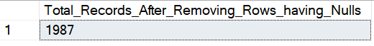

--Data Exploration

-- How many Transaction we have?

Select COUNT(transactions_id) Total_Transactions from Retail_Sales_Data

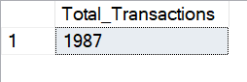

-- How many Unique Customers we have?

Select COUNT(DISTINCT customer_id) Total_Customers from Retail_Sales_Data

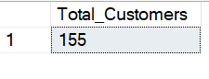

-- What are the Unique Categories?

SELECT DISTINCT category Total_Customers from Retail_Sales_Data

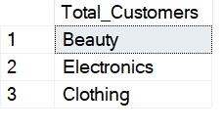

-- Data analysis and Solution of Business Problems

-- Q.1 Write a SQL query to retrieve all columns for sales made on '2022-11-05

SELECT * FROM Retail_Sales_Data

WHERE sale_date = '2022-11-05'

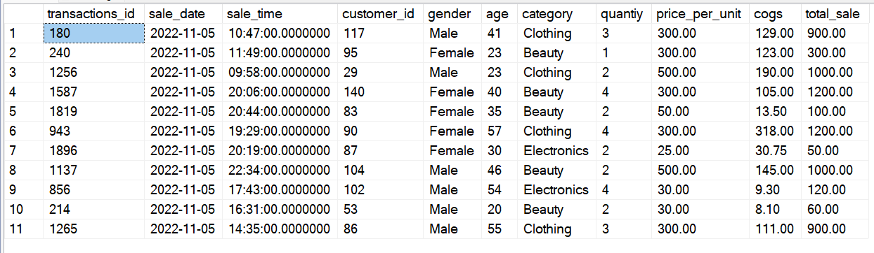

-- Q.2 Write a SQL query to retrieve all transactions where the category is 'Clothing'

-- and the quantity sold is more than 10 in the month of Nov-2022

SELECT * FROM Retail_Sales_Data

WHERE category = 'Clothing' AND FORMAT(sale_date,'MMM yyyy') = 'Nov 2022' and quantiy >= 4

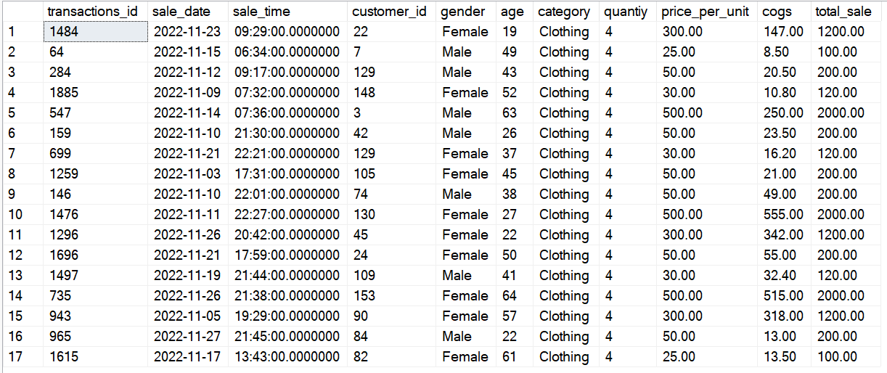

-- Q.3 Write a SQL query to calculate the total sales (total_sale) for each category.

SELECT category,

SUM(total_sale) as Total_Sales,

COUNT(*) Total_Orders

FROM Retail_Sales_Data

GROUP BY category

ORDER BY SUM(total_sale) DESC

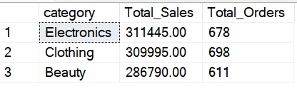

-- Q.4 Write a SQL query to find the average age of customers who purchased items from the 'Beauty' category.

SELECT

AVG(age) as Avg_Age_of_Customer

FROM Retail_Sales_Data

WHERE category = 'Beauty'

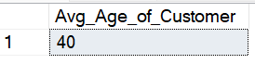

-- Q.5 Write a SQL query to find all transactions where the total_sale is greater than 1000.

SELECT * FROM Retail_Sales_Data

WHERE total_sale > 1000

ORDER BY transactions_id

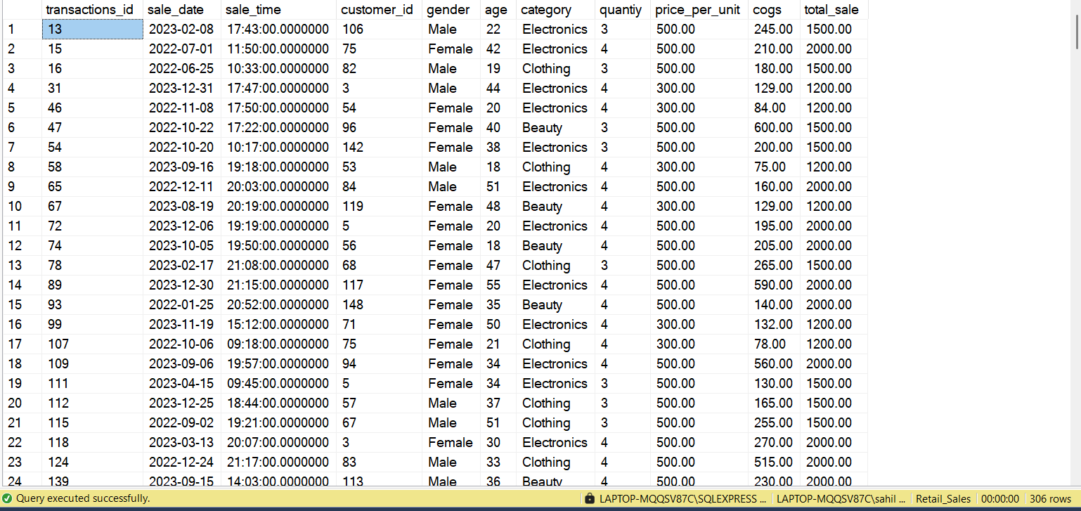

-- Q.6 Write a SQL query to find the total number of transactions (transaction_id) made by each gender in each category.

SELECT

category,

gender as Gender,

COUNT(*) Total_Transaction

FROM Retail_Sales_Data

GROUP BY category, gender

ORDER BY 1

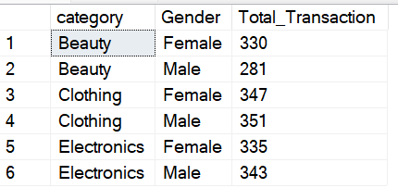

-- Q.7 Write a SQL query to calculate the average sale for each month. Find out best selling month in each year

SELECT

FORMAT(sale_date,'yyyy') as Years,

FORMAT(sale_date,'MMMM') Month_Name,

AVG(CAST(total_sale AS INT)) AS AVG_Sales_By_Month,

RANK() OVER(PARTITION BY FORMAT(sale_date,'yyyy') ORDER BY AVG(CAST(total_sale AS INT)) DESC) AS Rank_by_Sales

FROM Retail_Sales_Data

GROUP BY FORMAT(sale_date,'yyyy'),

FORMAT(sale_date,'MMMM')

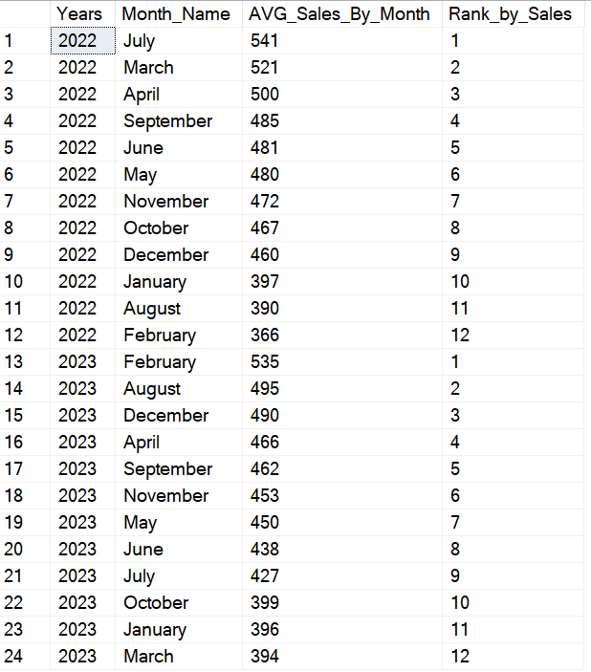

-- Best Selling Month in Each Year

SELECT

Years,

Month_Name,

AVG_Sales_By_Month

FROM (SELECT

FORMAT(sale_date,'yyyy') as Years,

FORMAT(sale_date,'MMMM') Month_Name,

AVG(CAST(total_sale AS INT)) AS AVG_Sales_By_Month,

RANK() OVER(PARTITION BY FORMAT(sale_date,'yyyy') ORDER BY AVG(CAST(total_sale AS INT)) DESC) AS Rank_by_Avg_Sales

FROM Retail_Sales_Data

GROUP BY FORMAT(sale_date,'yyyy'),

FORMAT(sale_date,'MMMM') )t

WHERE Rank_by_Avg_Sales = 1

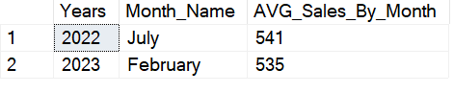

-- Q.8 Write a SQL query to find the top 5 customers based on the highest total sales

SELECT TOP 5 customer_id,

SUM(total_sale) as Total_Sales_by_Customer

FROM Retail_Sales_Data

GROUP BY customer_id

ORDER BY 2 DESC

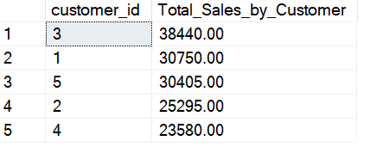

-- Q.9 Write a SQL query to find the number of unique customers who purchased items from each category.

SELECT

category,

COUNT(DISTINCT customer_id) Total_Unique_Customers

FROM Retail_Sales_Data

GROUP BY category

ORDER BY 2 DESC

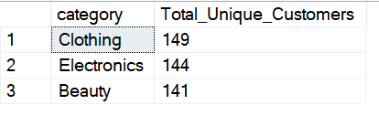

-- Q.10 Write a SQL query to create each shift and number of orders (Example Morning <=12, Afternoon Between 12 & 17, Evening >17 and rest is of Night)

SELECT

CASE

WHEN DATEPART(HH,sale_time) < 12 THEN 'Morning'

WHEN DATEPART(HH,sale_time) >= 12 AND DATEPART(HH,sale_time) < 17 THEN 'Afternoon'

WHEN DATEPART(HH,sale_time) >= 17 AND DATEPART(HH,sale_time) < 21 THEN 'Evening'

ELSE 'Night'

END AS Time_Shift, COUNT(*) Total_Transaction_Orders

FROM Retail_Sales_Data

Group by

CASE

WHEN DATEPART(HH,sale_time) < 12 THEN 'Morning'

WHEN DATEPART(HH,sale_time) >= 12 AND DATEPART(HH,sale_time) < 17 THEN 'Afternoon'

WHEN DATEPART(HH,sale_time) >= 17 AND DATEPART(HH,sale_time) < 21 THEN 'Evening'

ELSE 'Night'

END

ORDER BY 2 DESC

